Mother’s Day Brunch Menu

RustiK Caesar Salad 8/16
romaine | nappa cabbage | Grana Padano parmesan cheese |croutons |lardons | RustiK anchovy dressing

RustiK Greens 8/16 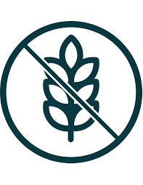 
mixed greens | shaved vegetables | toasted almonds | mustard vinaigrette

Eggs Benedict 22
poached eggs | hollandaise | peameal, spinach or smoked salmon |English muffin | home fries, caesar or green salad

Bacon & Spring Pea Spanish Frittata 22
free run eggs | peas | mascarpone cheese | double smoked bacon | potatoes | sprout & herb salad

Belgium Waffles 15
berry compote | maple syrup | Chantilly whipped cream

Cavatappi Pasta and Cheese 18
cavatappi pasta | rich cheese sauce | toasted breadcrumbs | jalapenos

Smoked Salmon w/ Croissant 23
smoked salmon | capers | red onion | whipped cream cheese

RustiK Brunch Burger 24

6oz house ground beef patty | fried egg | brioche bun | bacon | cheddar cheese | lettuce | tomato | pickle | chipotle aioli |home fries, caesar or green salad

Steak & Eggs 29
grilled sirloin | two eggs | demi glaze | home fries, caesar or green salad
Add shrimp 12 chicken 14 Salmon 16

=Gluten Free =Vegetarian
Gluten free substitutes available add $2.50
Please mention any allergies or dietary restrictions to your server

